Technology and Therapy using AI & Mixed Reality

**(Harmony)**

**Graduation Project**

**By**

Mahmoud Ahmed Mohamed

Eslam Mostafa Elsheikh

Alaa Basher Mohammed Abdullah

Ahmed Mohammed Mohammed

Nada Eldqn Amer

Mariam Emam Elsayed

Mariam Samy Elsaid

Ethar Mahmoud Abdel Samie

Ehsan Mohamed Mohammed

Aya Ayman Hassona

**A project submitted in partial fulfilment of the**

**requirements for the degree of Bachelor of Science**

**Information Technology**

**Supervised by**

Dr. Waleed Mohamed

Dr. Mohamed Handosa

Eng. Nawal Shaltout

2023/2024

**Abstract**

**Acknowledgement**

We would like to thank our great parents who spare no effort for helping and supporting us

all the time, we promise we will continue doing our best to make them proud of their

sons/daughters. We also give many thanks to our supervisor, Dr. Waleed Mohamed and Dr. Mohamed Handosa, who trusted and helped us and wish them all success in their life. And

of course, we won’t forget our friendly guide Eng. Nawal Shaltout for supporting us and putting unconditional effort to help us reach what we’ve reached. For those students who will read this report in the next years, we hope it will help you in your projects. We had a great time in Faculty of Computer and Information Sciences, we learned many things, and now it’s the time to use what we’d learnt.

Table of Contents

**Chapter 1: Introduction** 6

1.1 Problem Definition 6

1.2 Project Objectives 6

1.3 Scope 7

1.4 Project Timeline 9

1.5 Document Organization 11

**Chapter 2: Literature Review** 12

**Chapter 3: System Analysis** 13

Introduction 13

3.1 System Requirements 13

3.1.1 Functional Requirements: 13

3.1.2 Non-Functional Requirements: 14

3.1.3 User Requirements: 14

3.2 Development Methodology 16

3.2.1 Use Case Diagram 16

3.2 2 Activity Diagram 17

3.2.3 State Diagram 23

3.3 System Architecture 24

3.4 Tools and Languages 25

**Chapter 4: System Design** 28

4.1: Class Diagram 28

4.2 Data base Design or Algorithms 29

4.3 Interface Design 31

# **Chapter 1: Introduction**

## 1.1 Problem Definition

In an era defined by rapid technological advancement, mental health challenges, including anxiety disorders, remain a prevalent barrier to emotional well-being for many individuals. Recognizing this pressing need, our graduation project introduces a pioneering solution by combining Virtual Reality (VR) technology with an Artificial Intelligence (AI)-powered application. This innovative integration seeks to offer holistic support to individuals grappling with anxiety, equipping them with tools to overcome distress, navigate symptoms, and fortify their emotional strength. Our goal is to extend this transformative approach beyond specific conditions, providing a versatile solution for addressing various forms of anxiety and promoting mental wellness on a broader scale.

## 1.2 Project Objectives

Our project's core focus is on creating an interactive application that utilizes the immersive potential of VR technology. This application aims to support individuals in addressing the challenges of anxiety. It will offer a variety of exercises, daily activities, and tracking systems, all augmented by AI-driven features. Our goal is to deliver a comprehensive platform that empowers individuals to effectively manage their anxiety and enhance their overall well-being.

## 1.3 Scope

Project Scope: VR-Integrated AI-Powered Application for Mental Health Support

**1. Technical Scope:**

- Virtual Reality (VR) Integration: Development and integration of VR technology to createimmersive environments conducive to exposure therapy, relaxation exercises, and real-life scenarios for OCD and phobia management.

- Artificial Intelligence (AI) Implementation: Incorporating AI-driven functionalities for personalized experiences, user interaction, cognitive behavior insights, and emotional support within the application.

**2. Feature Set:**

- Personalized User Profiles: Creation of customizable user profiles allowing input, editing and progress.

- Diverse Exercise Modules: Inclusion of deep breathing exercises, progressive muscle relaxation (PMR), and tailored exposure tasks aimed at managing anxiety and addressing compulsive behaviors.

- Daily Challenges and Tracking System: Implementation of daily challenges and a comprehensive tracking system to monitor user progress, including anxiety levels and task completion.

- AI-Powered Chatbot: Development of an AI-driven conversational interface leveraging natural language processing and machine learning for personalized guidance and emotional support.

- Cognitive Distortion Identification: Utilization of AI algorithms to identify and present cognitive distortions based on user survey responses.

- Interactive VR Environments: Development of interactive and customizable VR environments offering supportive scenarios and challenges for users.

**3. User Interface (UI) and User Experience (UX):**

- Intuitive and User-Friendly Design: Crafting an intuitive and aesthetically pleasing UI/UX for seamless navigation and engagement within the application.

- AI-Driven Personalization: Integrating AI-driven personalization to enhance user experiences and tailor exercises to individual needs and progress.

**4. Content and Data Management:**

- Content Development: Crafting exercises, challenges, and supportive scenarios that align with principles of mental health management.

- Data Security and Compliance: Implementation of robust data security measures to ensure user privacy and compliance with data protection regulations.

**5. Documentation and Reporting:**

- Project Documentation: Creation of detailed documentation outlining system architecture, functionalities, and guidelines for users and developers.

- Progress Reporting: Periodic reporting on project milestones, challenges, and progress to stakeholders and project supervisor.

## 1.4 Project Timeline

## 1.5 Document Organization

This project consists of six chapters. A brief description about the contents of each chapter is given in the following paragraphs:

* Chapter 1: introduction, include overview, problem definition, project objectives, project scope, document organization, project timeline.
* Chapter 2: literature review provides the reader with an overview of the previous related work, common technologies used, and the relation between our work and the related work.
* Chapter 3: system analysis, includes the analysis of existing system, system requirements, user requirements, system architecture, the tools, and languages used in our system.
* Chapter 4: system design, provides the system design including class diagram, database design and interface design.
* Chapter 5: system implantation sample application code, system testing, results of the investigation, and goals achieved.

# **Chapter 2: Literature Review**

We review the previous related work to our system, In the end of the chapter, we provide a comparison between the system we are going to build and the pervious similar related works.

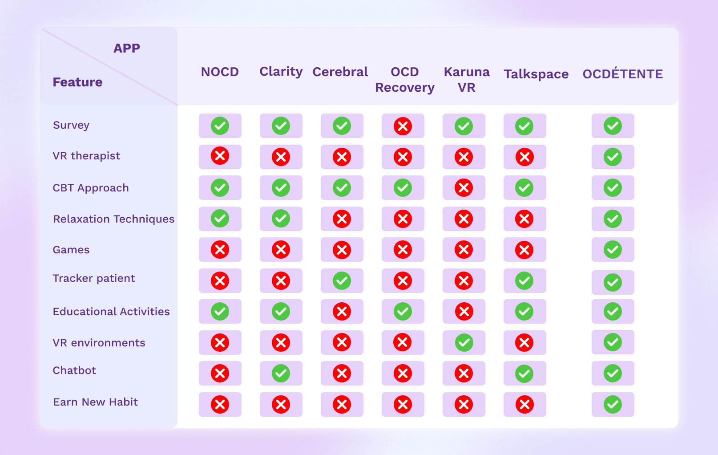

# **Chapter 3: System Analysis**

## Introduction

In this chapter we provide a detailed knowledge about our system including functional requirements, non-functional requirements, user requirements, system architecture, use case, and sequence diagrams. We can divide the process of analysis into three parts, which are determining requirements, system architecture, and development methodology.

## 3.1 System Requirements

### 3.1.1 Functional Requirements:

**1. Personalized User Profiles:**

- User Input: Allow users to input and edit information related to his symptoms and progress.

- Profile Review: Provide a functionality for users to review their personalized profiles.

**2. Diverse Exercise Modules:**

- Exercise Types: Include deep breathing exercises, progressive muscle relaxation (PMR), and tailored exposure tasks.

- Anxiety Management: Ensure exercises aim at managing anxiety and addressing compulsive behaviors.

**3. Daily Challenges and Tracking System:**

- Challenge Implementation: Implement daily challenges for users.

- Tracking Functionality: Develop a tracking system to monitor user progress, including anxiety levels and task completion.

**4. AI-Powered Chatbot:**

- Conversational Interface: Develop an AI-driven conversational interface.

- Natural Language Processing: Utilize natural language processing for personalized guidance and emotional support.

**5. Cognitive Distortion Identification:**

- AI Algorithms: Utilize AI algorithms to identify and present cognitive distortions based on user survey responses.

**6. Interactive VR Environments:**

- VR Development: Develop interactive and customizable VR environments.

- Supportive Scenarios: Offer supportive scenarios and challenges for users within the VR environment.

### 3.1.2 Non-Functional Requirements:

**1. Scalability:**

- User Growth: The system should be able to handle an increasing number of users and data.

**2. Performance:**

- Response Time: Ensure quick response times for user interactions with the system.

**3. Security:**

- Data Security: Implement measures to secure user data and maintain privacy.

**4. Reliability:**

- System Availability: Ensure high availability and minimal downtime.

### 3.1.3 User Requirements:

**1. User-Friendly Interface:**

- Intuitiveness: The interface should be user-friendly and intuitive for users to navigate easily.

**2. Customization:**

- Personalization: Allow users to customize their profiles and exercise experiences.

**3. Progress Tracking:**

- Visual Representation: Provide a visual representation of user progress over time.

**4. Emotional Support:**

- Chatbot Interaction: Users should feel emotionally supported through interactions with the AI-powered chatbot.

**5. VR Experience:**

- Engaging VR: Ensure the VR environments are engaging and contribute positively to the user experience.

These requirements serve as a foundation for the development and evaluation of our system.

## 3.2 Development Methodology

### 3.2.1 Use Case Diagram

### 3.2 2 Activity Diagram

### 3.2.3 State Diagram

## 3.3 System Architecture

## 3.4 Tools and Languages

* **MACHINE LEARNING**
  + **TensorFlow**:
    - Reference: TensorFlow. (n.d.). Retrieved from <https://www.tensorflow.org/>
    - Description: TensorFlow is a widely-used open-source machine learning framework developed by Google. It provides comprehensive support for building and deploying machine learning models across various platforms.
  + **Anaconda**:
    - Reference: Anaconda. (n.d.). Retrieved from <https://www.anaconda.com/>
    - Description: Anaconda is a popular distribution of the Python and R programming languages, primarily used for data science, machine learning, and scientific computing. It offers a wide range of pre-installed libraries and tools for efficient package management and deployment.
  + **Python**:
    - Reference: Python. (n.d.). Retrieved from <https://www.python.org/>
    - Description: Python is a versatile and high-level programming language known for its simplicity and readability. It has extensive support for various libraries and frameworks, making it a preferred choice for machine learning, data analysis, web development, and more.
* **UI/UX**
  + **Figma**:
    - Reference: Figma. (n.d.). Retrieved from <https://www.figma.com/>
    - Description: Figma is a cloud-based design tool used for creating user interfaces, prototypes, and collaborative design projects. It offers features for real-time collaboration, version control, and seamless integration with other design and development tools.
* **FLUTTER**
  + **Dart**:
    - Reference: Dart. (n.d.). Retrieved from <https://dart.dev/>
    - Description: Dart is a programming language developed by Google, primarily used for building web and mobile applications. It serves as the primary language for developing applications using the Flutter framework, offering features like strong typing, asynchronous programming, and object-oriented design.
* **BACKEND**
  + **MySQL**:
    - Reference: MySQL. (n.d.). Retrieved from <https://www.mysql.com/>
    - Description: MySQL is an open-source relational database management system known for its reliability, performance, and scalability. It is widely used for building backend databases for web applications, supporting features like transactions, replication, and high availability.
  + **Laravel**:
    - Reference: Laravel. (n.d.). Retrieved from <https://laravel.com/>
    - Description: Laravel is a free and open-source PHP web framework known for its elegant syntax, expressive ORM, and robust features. It simplifies the development of web applications by providing tools for routing, authentication, database management, and more.
  + **Pusher**:
    - Reference: Pusher. (n.d.). Retrieved from <https://pusher.com/>
    - Description: Pusher is a hosted service that provides real-time communication channels via WebSocket and HTTP-based APIs. It simplifies the implementation of real-time features like chat, notifications, and presence in web and mobile applications.
  + **Docker**:
    - Reference: Docker. (n.d.). Retrieved from <https://www.docker.com/>
    - Description: Docker is an open-source platform used for building, deploying, and managing applications within lightweight and portable containers. It enables developers to package applications and their dependencies into standardized units, ensuring consistency across development, testing, and production environments.
  + **Postman**:
    - Reference: Postman. (n.d.). Retrieved from <https://www.postman.com/>
    - Description: Postman is a popular collaboration platform for API development, testing, and documentation. It offers a user-friendly interface for designing, testing, and debugging APIs, as well as features for automating API workflows, monitoring performance, and generating documentation.

**VR Development**

* **Blender**:
  + Reference: Blender. (n.d.). Retrieved from <https://www.blender.org/>
  + Description: Blender is a powerful open-source 3D creation suite used for modeling, animation, rendering, and more. It offers a wide range of features, including sculpting, texturing, rigging, simulation, and compositing. Blender is extensively used in various industries for creating immersive virtual reality experiences.
* **Unity**:
  + Reference: Unity. (n.d.). Retrieved from <https://unity.com/>
  + Description: Unity is a leading cross-platform game development engine developed by Unity Technologies. It supports the creation of both 2D and 3D games and provides a visual editor along with scripting capabilities in C#. Unity is widely used in game development as well as in the creation of augmented reality (AR) and virtual reality (VR) experiences.

# **Chapter 4: System Design**

In this chapter, we can design the system considering the determined requirements. In section 4.1, we provide the class diagram which includes the classes of the system, their attributes, operations, and relations. Then we provide the design of database tables in section 4.2. The design of the mobile application is included in section 4.3.

## 4.1: Class Diagram

A class diagram describes the structure of a system by showing the system's classes, their attributes, operations (or methods), and the relationships among objects. Figure 4.1 shows the class diagram that includes classes representing all system components.

## 4.2 Data base Design or Algorithms

 ERD (Entity Relationship Diagram) is a data modeling technique has graphically illustrated

an information system's entities and the relationship between those entities. This ERD show the

entities and the relationship between them. Each entity contains attributes with identifying

the foreign key and the primary key.

## 4.3 Interface Design

Project Logo:

* The Logo reflects the struggles of individuals with recurring thoughts and obsessions, emphasizing the presence of a positive avenue for improvement through virtual reality.



Figure 4.3.1– Logo

**Onboarding Screens:**

At the beginning, the user goes through the initial pages, starting with onboarding screens.

                                  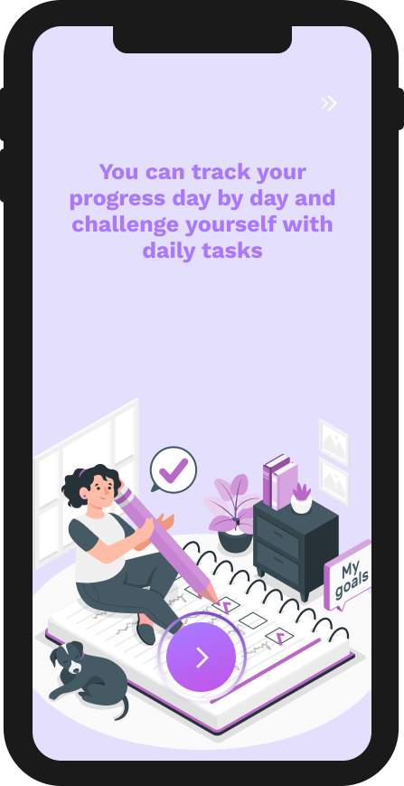

Figure 4.3.3–Onboarding2

Figure 4.3.2– Onboarding1

**Sign Up & Login Pages:**

* The user will log in to start interacting with our application.
* If it is the first time to the user in our application and he does not have an account, he will sign Up.

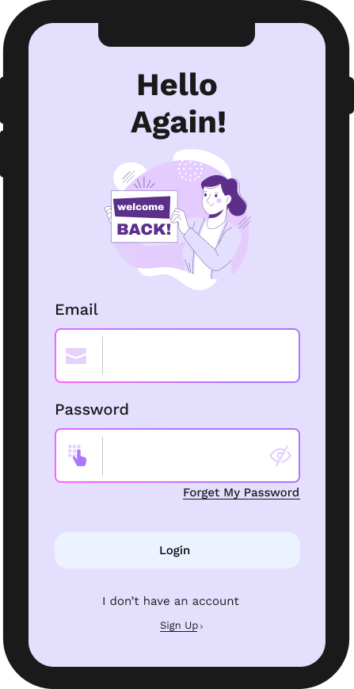

Figure 4.3.5– Login

Figure 4.3.6– Sign Up

**Survey Page:**

* The survey questions from the Yale-Brown Obsessive Compulsive Scale.

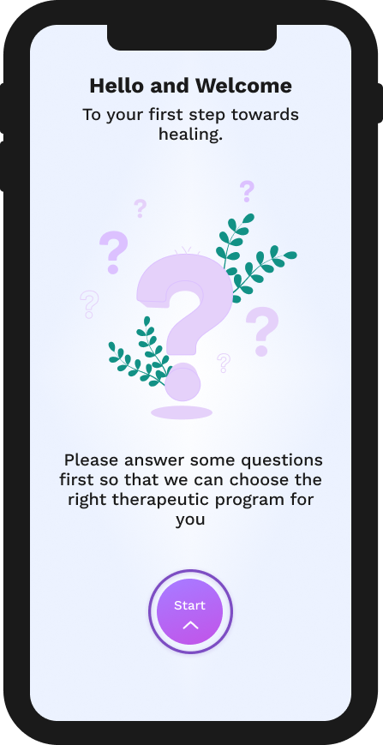                       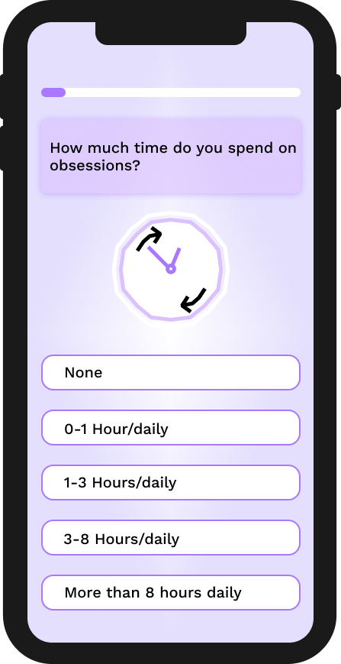

           Figure 4.3.7– Start Survey                                                              Figure 4.3.8– Q1

**Other Surveys Samples:**

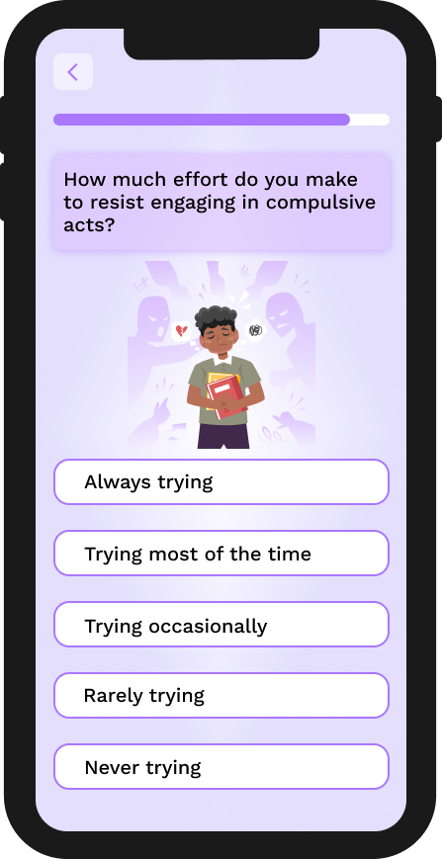                                   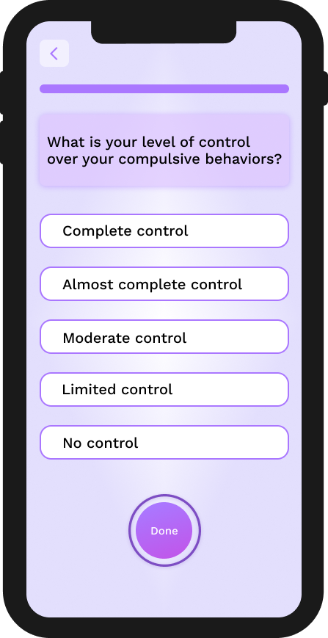

                   Figure 4.3.11– Q9                                                                             Figure 4.3.12– Q10

**End Of Survey:**

* **Survey Result** according to the user’s answers we will recommend them some CBT ACTIVITIES (as shown in figure 4.3.15) for their healing journey.

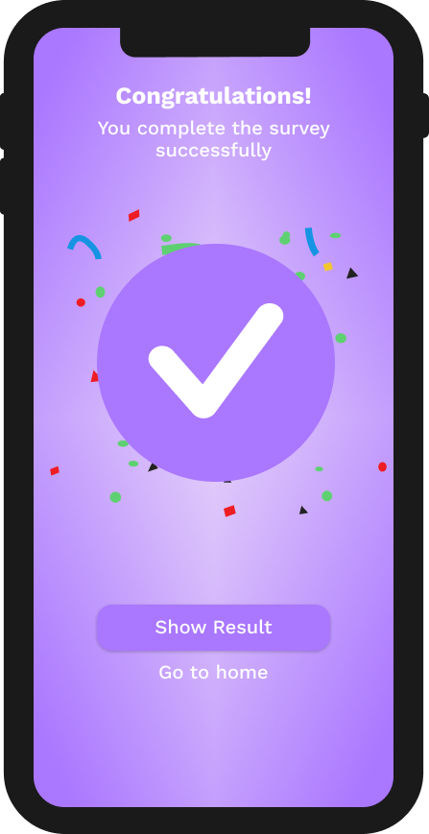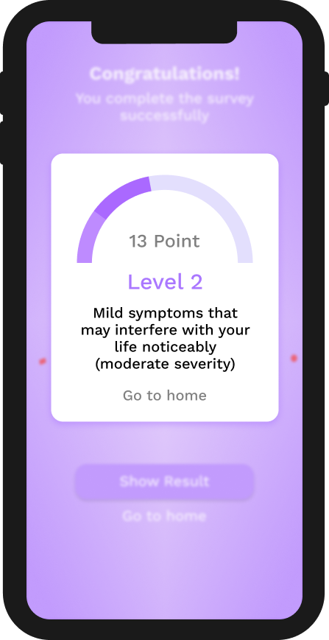

Figure 4.3.13– Congratulations                                                        Figure 4.3.14– Result

**Home Page:**

The home page features the user's daily interaction and a patient plan based on a set of activities and optional Survey.

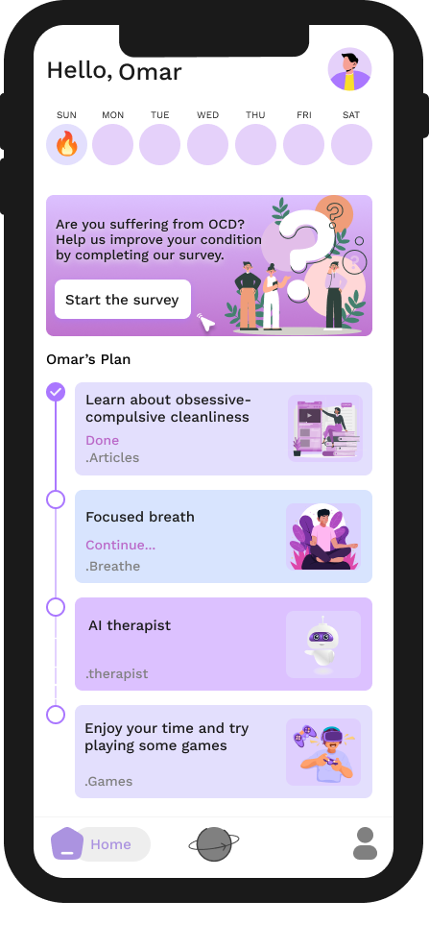

    Figure 4.3.15– home page

**Discover page:**

It includes activities such as AI therapist, games, calming and relaxation exercises, adding and enhancing hobbies, incorporating memories through photos, and educational content with articles and Podcasts.

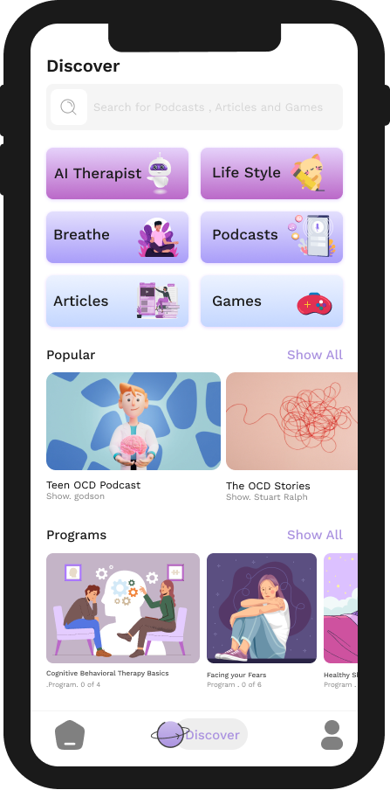

Figure 4.3.16– Discover

**AI therapist:**

To respond to any user inquiries.

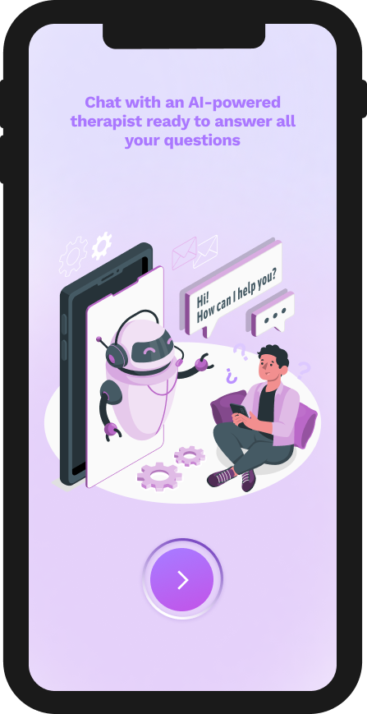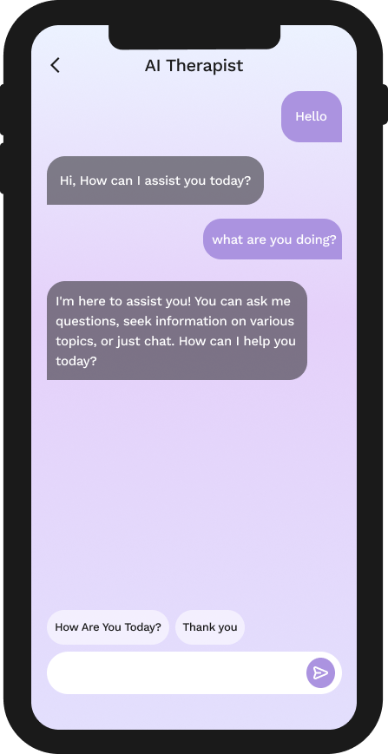

Figure 4.3.17–Start                                                                    Figure 4.3.18– Chat

**Lifestyle:**

* **Habit**

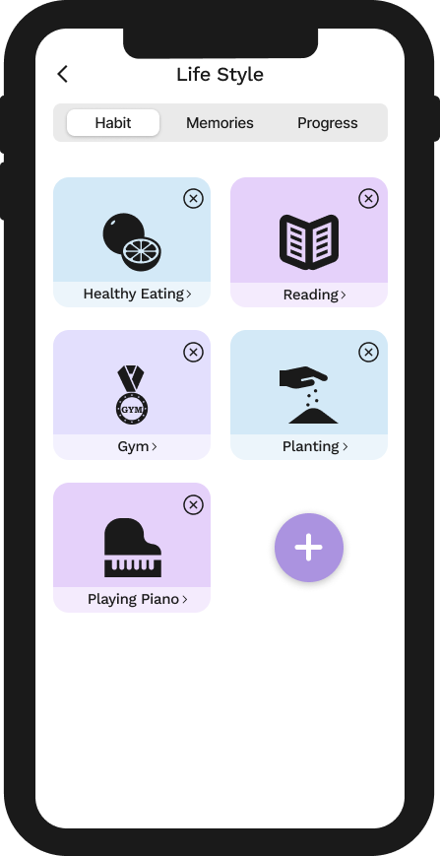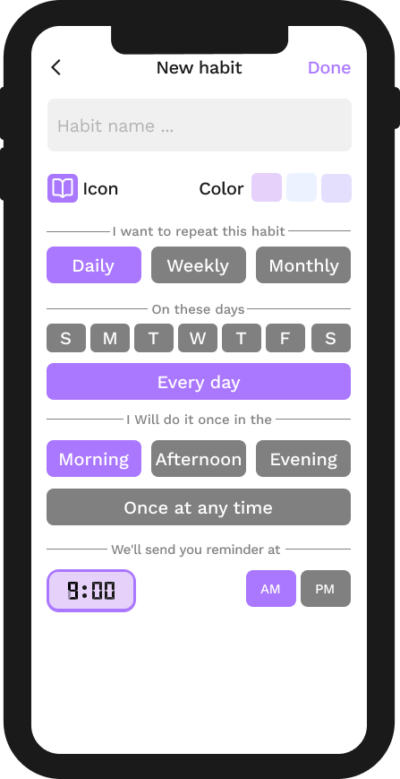

              Figure 4.3.19– Habit                                                                 Figure 4.3.20– New Habit

**Notes:**

User Can write thoughts and ideas here to remember them later

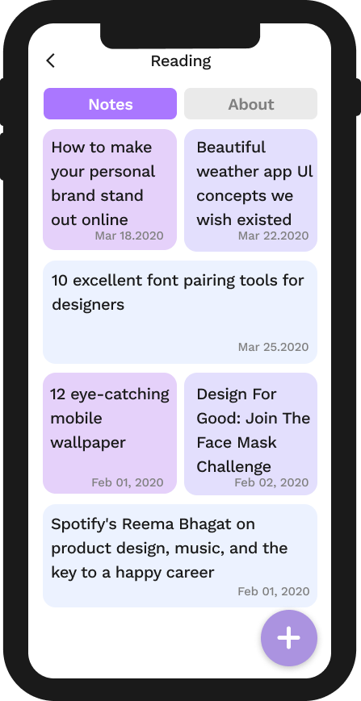                        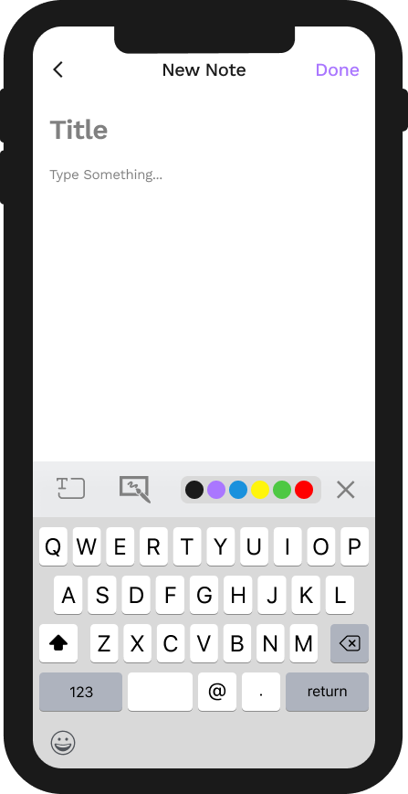

              Figure 4.3.21– Notes                                                                           Figure 4.3.22– New Note

**Memories:**

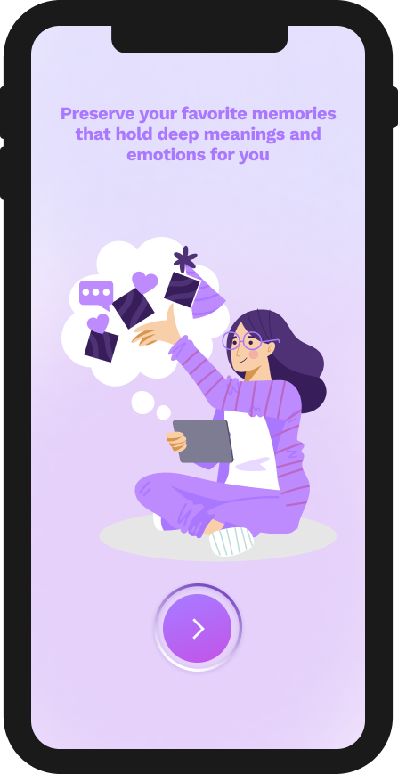                 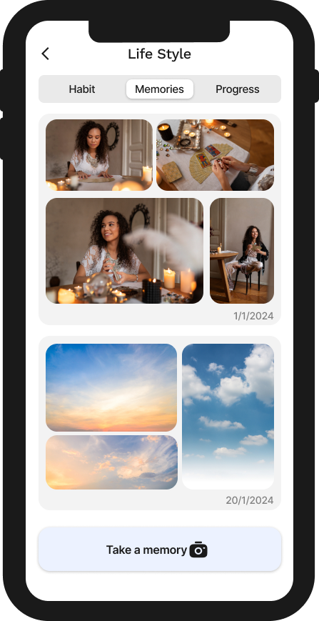

                 Figure 4.3.23– Start                                                                Figure 4.3.24– Memories

**Progress:**

                User Weekly & Daily progress

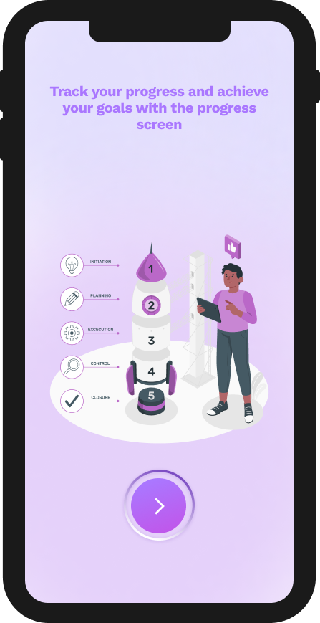                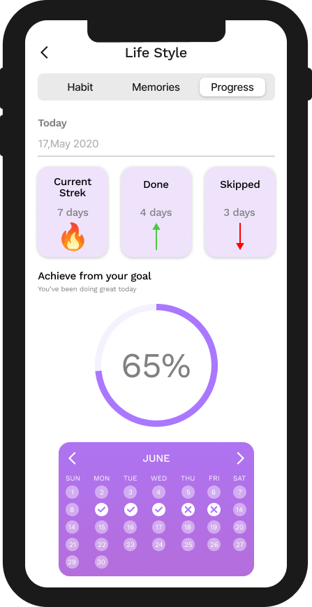

              Figure 4.3.25– Start                                                                  Figure 4.3.26– Progress

**Games:**

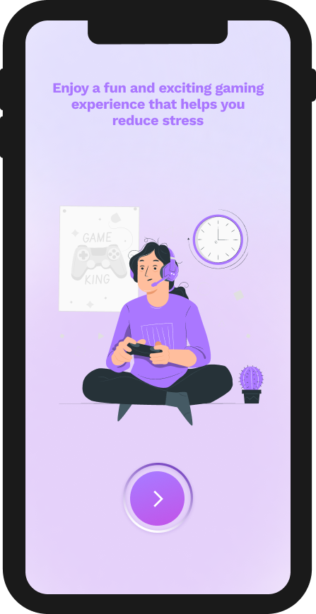                     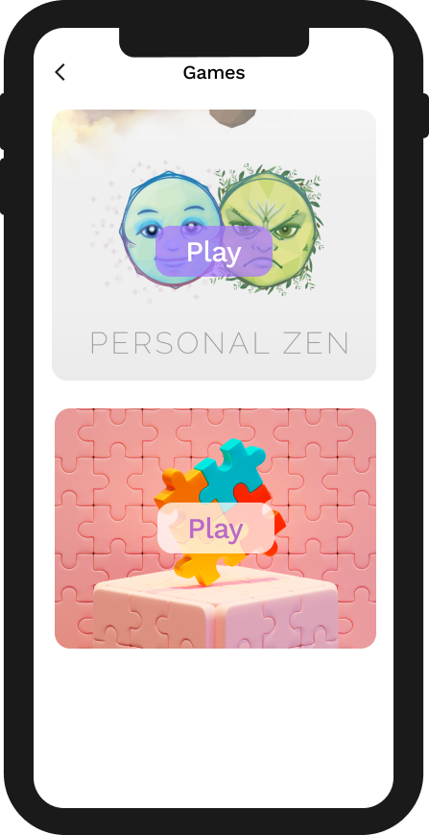

                     Figure 4.3.27– Start                                                                    Figure 4.3.28– Games

**Articles:**

 User can read interesting articles and topics on the screen

                     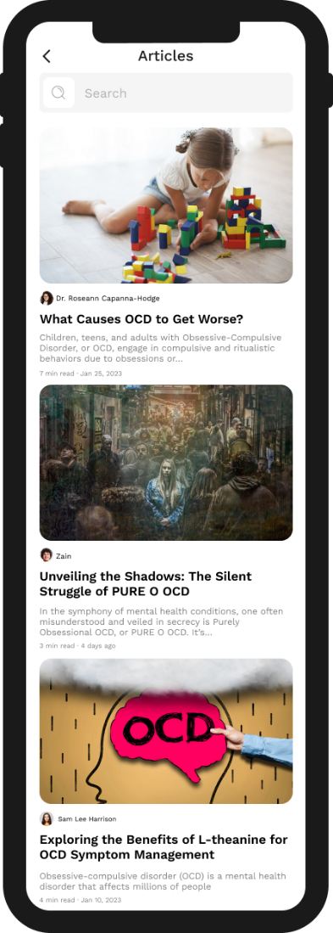

                  Figure 4.3.29– Start                                                             Figure 4.3.30– Articles

**Breathe:**

          Enjoy moments of calm and contemplation to renew your energy and         achieve inner harmony

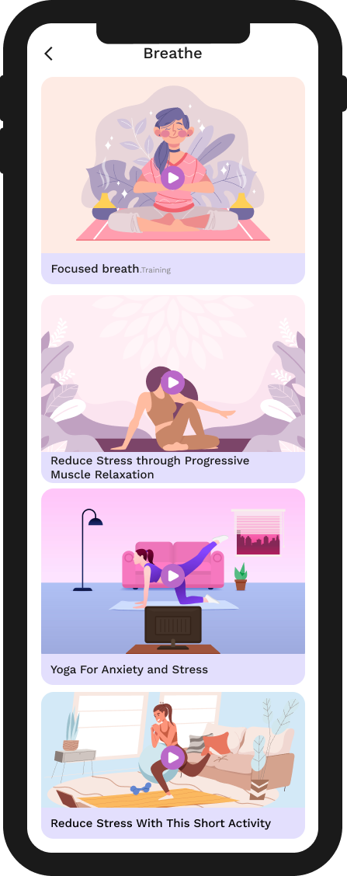                 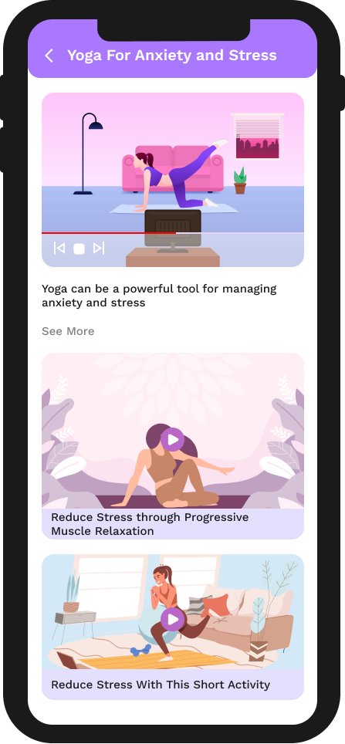

               Figure 4.3.31– Breathe                                             Figure 4.3.32– Play Video

**Podcasts**

               Listen to the new podcast to get the latest information

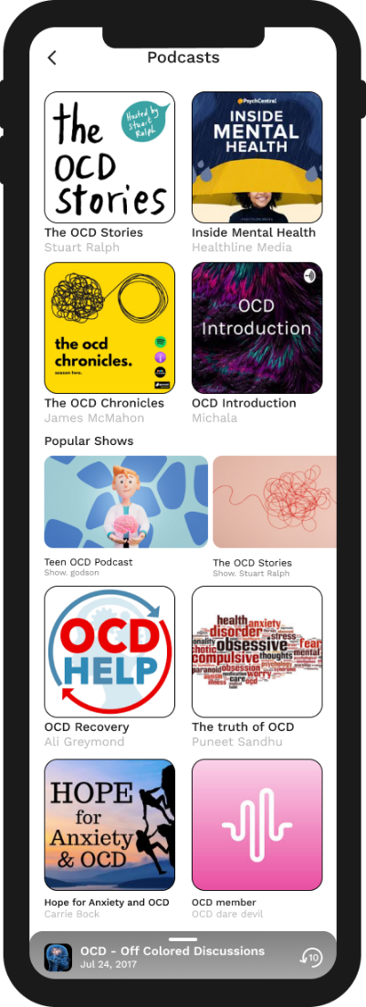                       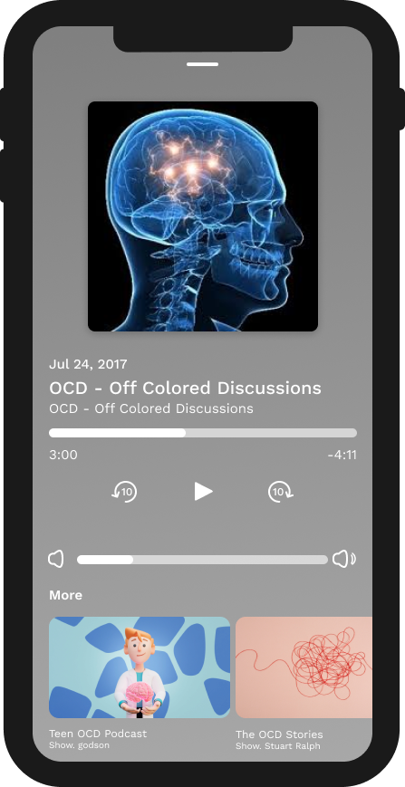

    Figure 4.3.33– Podcasts                                                       Figure 4.3.34– Play podcast

**User Profile:**

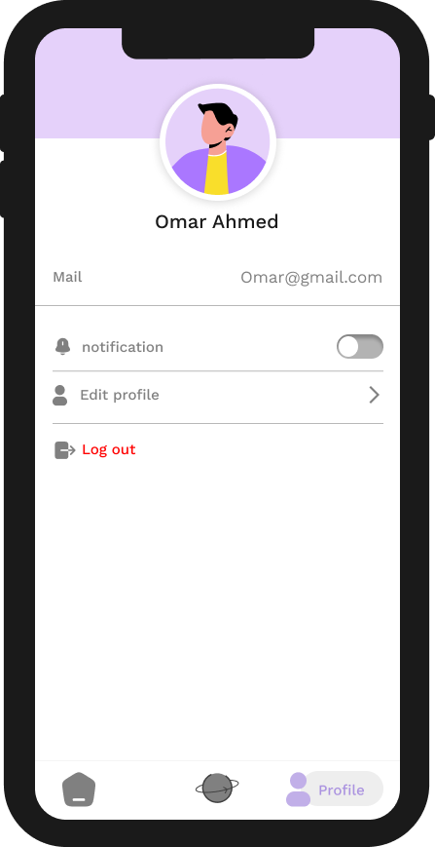                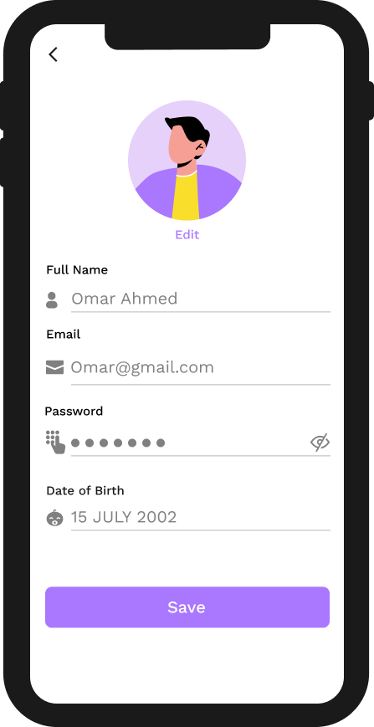

              Figure 4.3.35–Profile                                                              Figure 4.3.36– edit Profile

**4.4 Summary**:

In this chapter we make the reader look at our system design. Section 4.1 provides class diagram for application. We also designed in Section 4.2 the tables of the database. We showed the reader the interface design of the application with a description of its usage in Section 4.3. We can now start the implementation process. In the next chapter, we will map our system design for implementation.